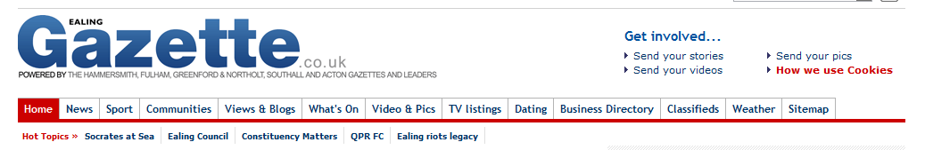

Southall curry chef wins praise from Cameron
Dec 7 2012 By James Gates
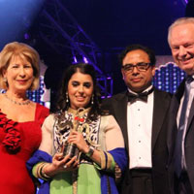
Jenny Bond, Dipna Anand, Enam Ali and Francis Maude at the British Curry Awards.
THE head chef of Brilliant restaurant in Southall has earned high praise from no less a curry fan than Prime Minister David Cameron.
Speaking via a video link to the British Curry Awards, Mr Cameron opened the envelope that revealed female chef Dipna Anand, of Brilliant Restaurant, had scooped the Special Inspiration award.
He told the Battersea audience: “Each year we honour someone very special and in this gold envelope I have the name of that person.
“It gives me great pleasure to announce the Special Inspiration award goes to Dipna Anand.“The British curry industry is part of British culinary life and it is great to see you recognised for that tonight so congratulations on this fantastic achievement,” he told her.
Dipna Anand, also a lecturer at the University of West London, said: “Being honoured by the Prime Minister is truly a privilege and an achievement I will cherish forever. This is most definitely my biggest achievement yet and the start to many new things.
“I am thankful to my parents who have always encouraged me to go that extra mile and supported me in every decision I have made.
“My father, Gulu, is my role model and after having seen him run our restaurant so successfully for the last 37 years, I too want to be as successful as him and want to make him more proud.”
She added that she is working on a cookery book which she hopes to publish early next year.
Ms Anand’s award is the latest in a long line of awards for the restaurant, which is a personal favourite of Prince Charles and celebrity chef Gordon Ramsay.
The competitors were judged on menu, wine list, exterior and interior decor and plate presentation.
More than 270,000 nominations were received from diners across the country.

